ASSIGNMENT OF HTML, CSS AND JS FUNDAMENTAL

HARMANDEEP KAUR

STUDENT ID- 200570592

LAB1

STEP 1: In first step we make the new folder with the name of personal webpage.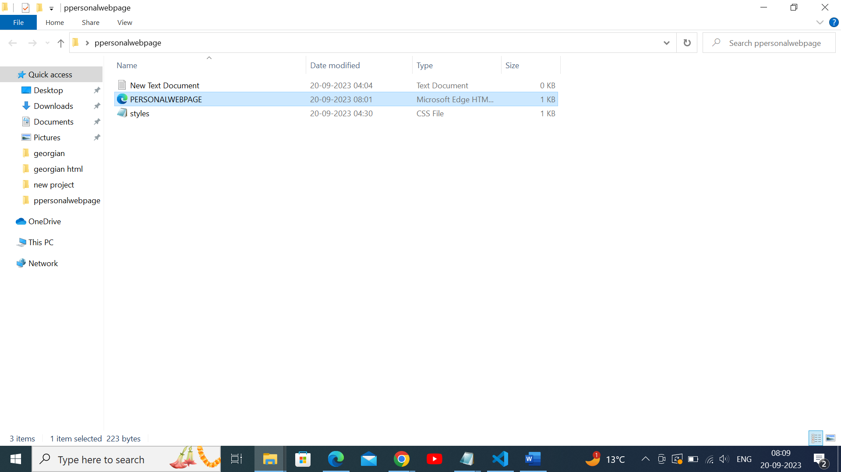

STEP2: In second step, make the different headings and subheadings of h1 to h2.

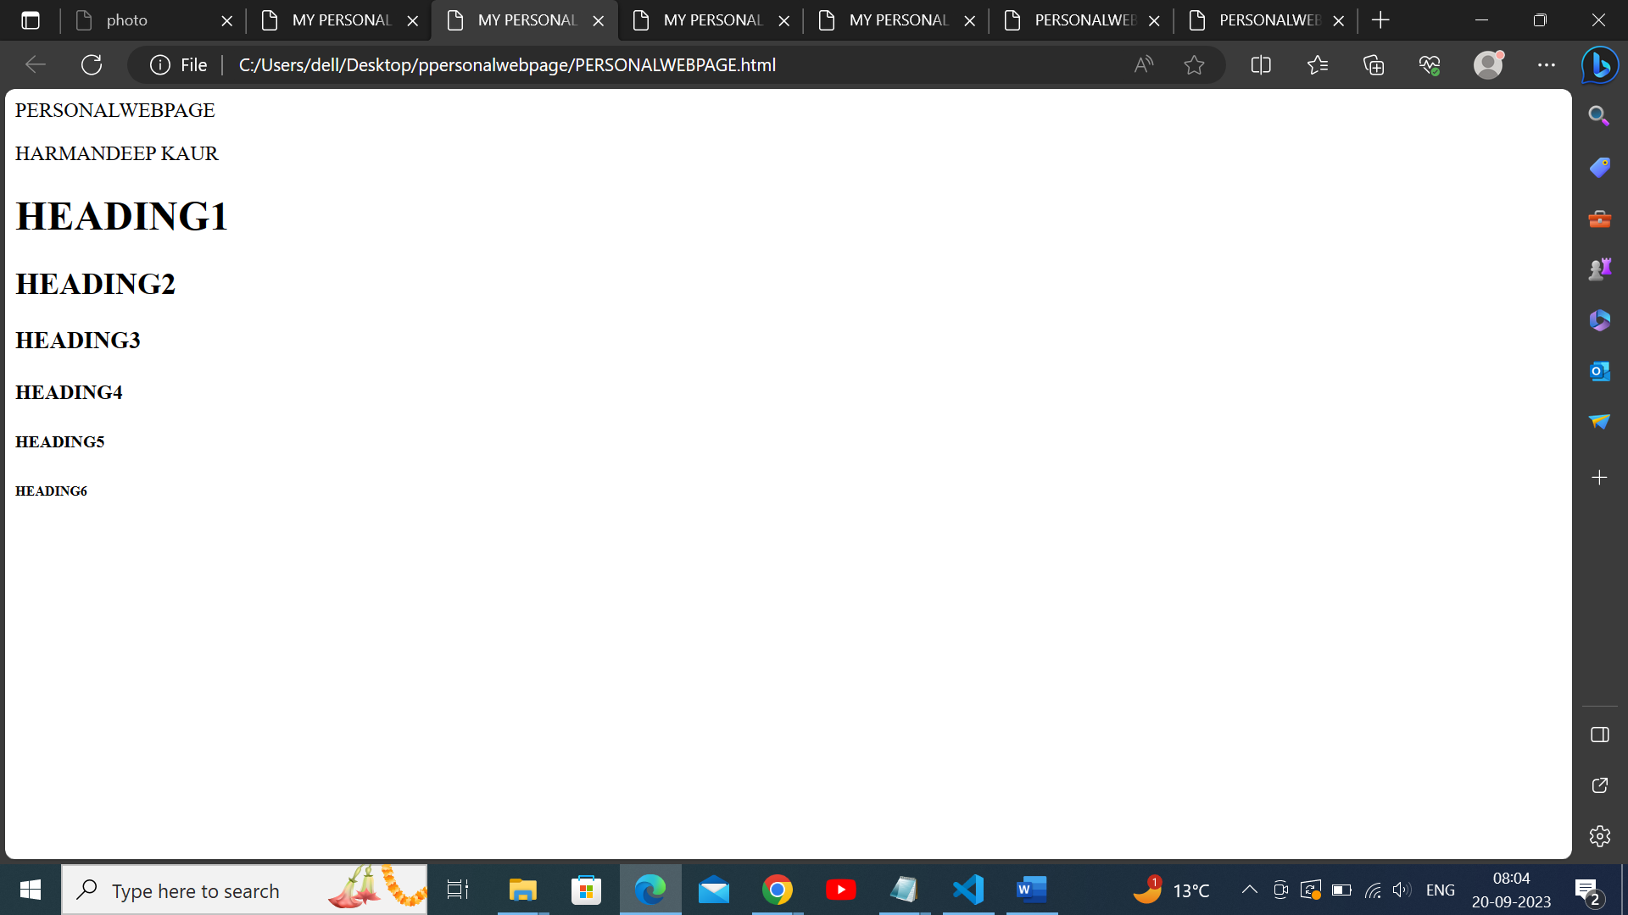

STEP 3:

In this, we make navigation bars with links “home”, ” about me”,”portofolia”,”contect ”.

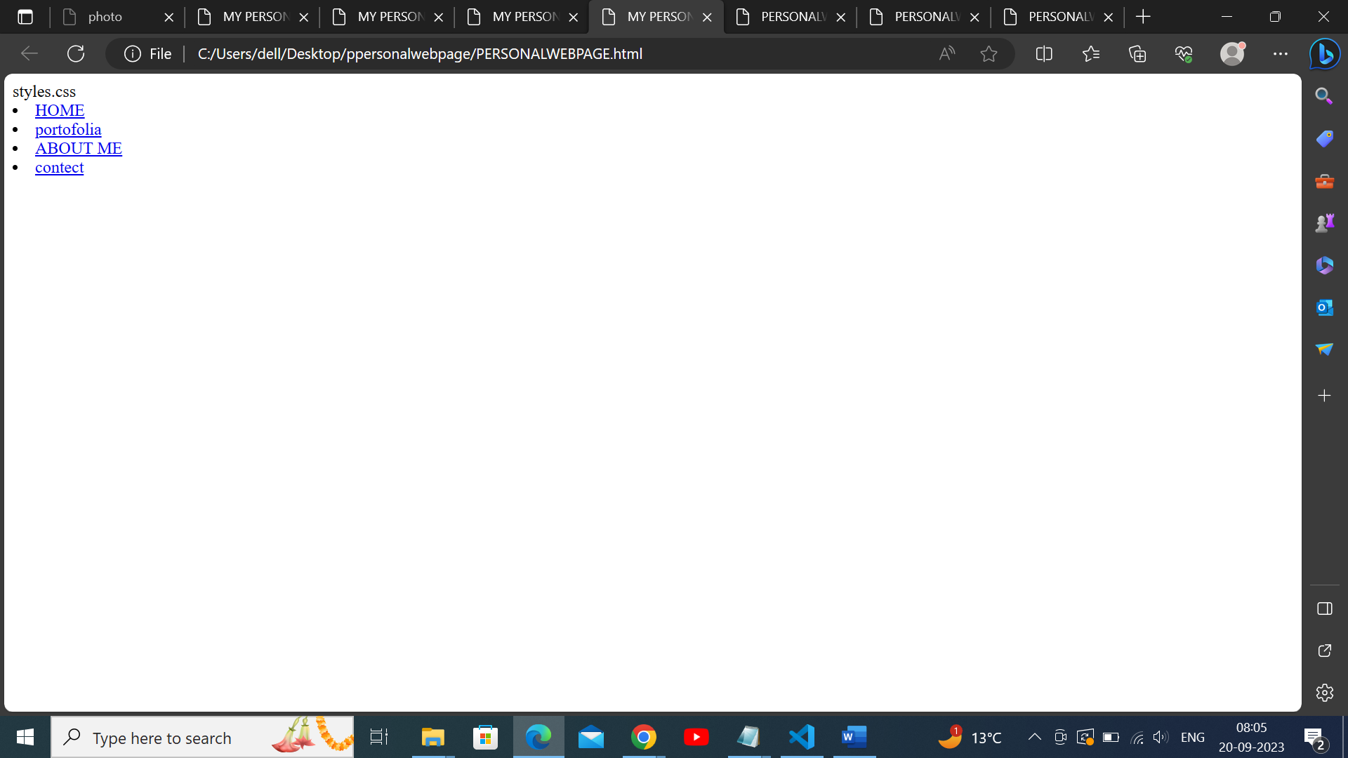

STEP 4:

In step 4 , we include the image using <img>.

